**EventApp Acadguild Project**

**Synopsis**

**The project is designed to add new events through administrator and also has feature to update and delete event’s with confirmation messages and has one login portal for user and admin.**

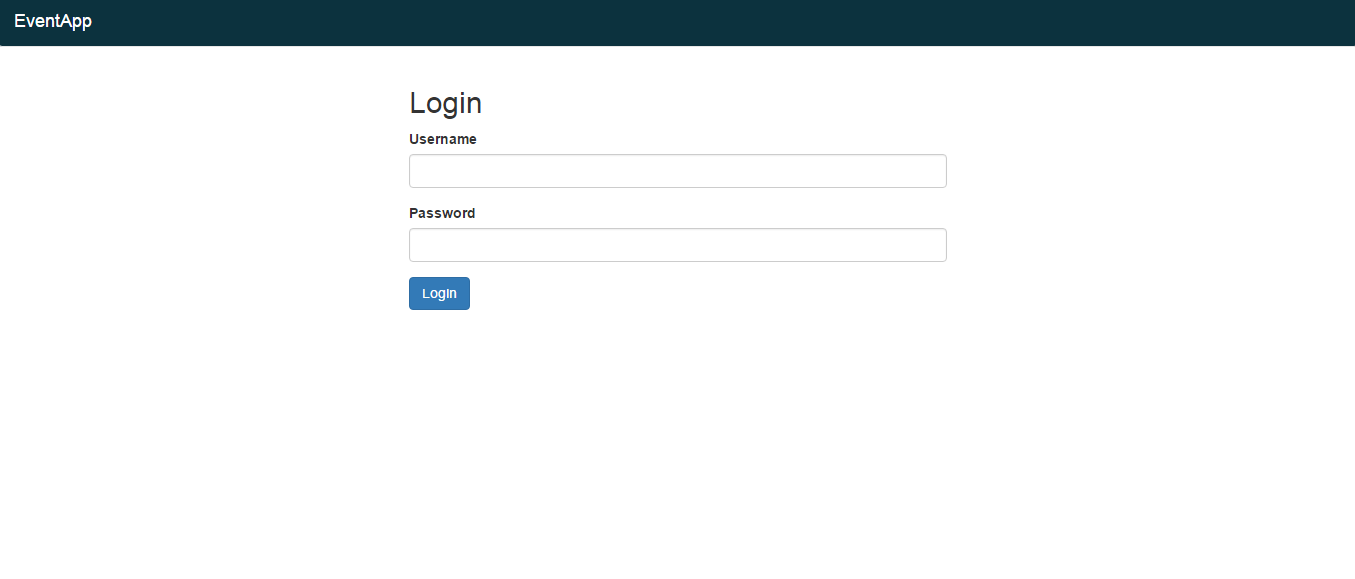

**Administrator Profile:**The administrator portal can be logged in by using administrator as username and password.

Admin add events based on event name, date ,time, address, city, pincode.

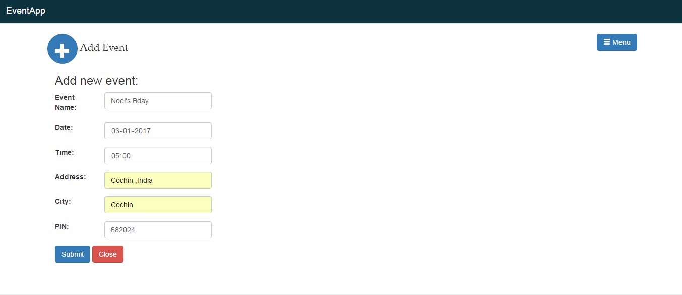

**User Profile:**

The user profile can view events updated by admin according to dates provided. To access user profile type in noel in username and password.

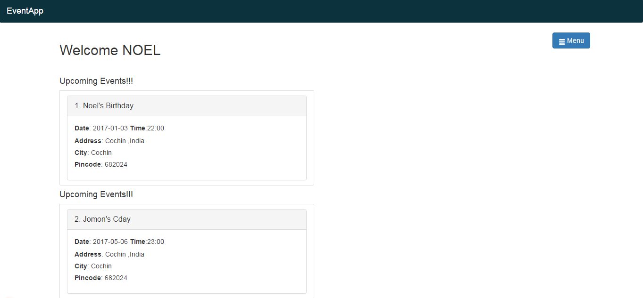

**Tools used**

* Have used angular2 cli to start project
* Used guards for securing links for admin and user.
* Have used accordion for displaying events as list
* For storing data used angular2-in-memory-web-api and event-data.ts for storing data through observables.
* Used ng2-dropdown for dropdown menu.